Personal portfolio (release 1)
My name is Eric, a developer of TNT team. We made a cloud server called “Mediavault” to save users’ media files, like e-book, picture, video, audio online. Obviously, the solidarity and precise division is necessary for a group to finish their project, especially for this large project. So, in my group, the division of labour is clear-cut, each one being charged with specific responsibilities. And my job is to build the account system.
A good and safe account system is important for the users, because no one want to lose their account and data. In order to release the functions, I do somethings below:
- Register system.
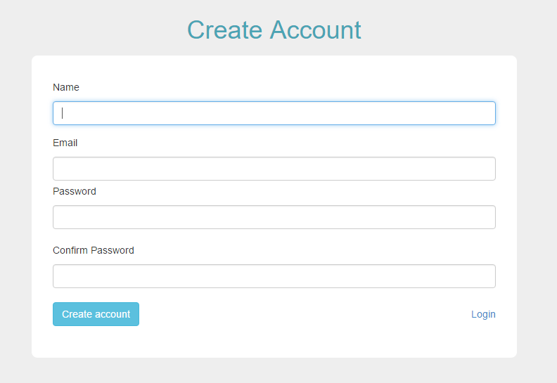
I connected the register form and database so that information users’ input could store in the “user_information” table of the “mediavault” database. This form allows user to input some basic information. Name is an unique identification, which meas a user cannot register accounts by using same names. And “password” and “confirm password” should be same, or system will show an error information. And, most importantly, email is used to verify the register information.

- Verify register information
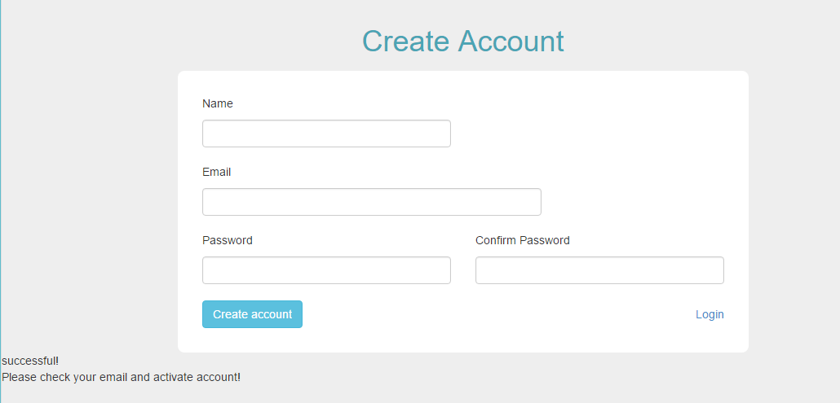
I built the verify account system by using PHP, and some network techniques like HTTP, SMTP... And I created our own account for SMTP server in order to send a verify email to users when they finished the register. Obviously, when users successfully register their account, they will see some information which is used to remind them to activate their accounts. And system will send an email to their email box. It is easy to activate account, just click the link and open the website --- successful!

- Login function:
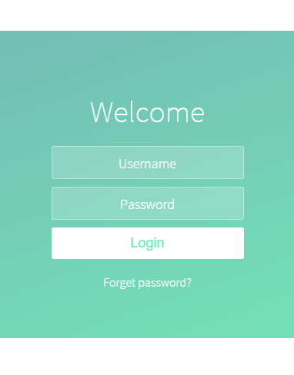
I used javascript to judge whether users input the information or not. If they don’t input the username or password in the box, an error will occur and they won’t login. Also, I wrote PHP code in order to combine the front-end and back-end. When users input a correct username and password, they can login in and access into the home page. 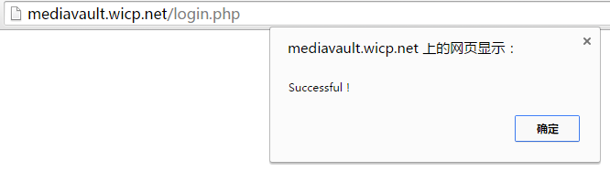
Otherwise, they cannot login. Error Account!
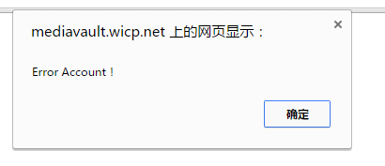

- Find password function: It is unavoidable that users forget their password. So, I created this function to help those people who forgot the password. Users can use their email to apply for password recovery. And system will send them an email and allow them to input a new password.
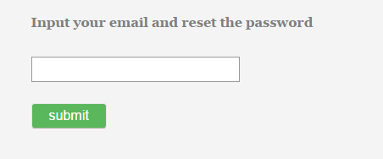
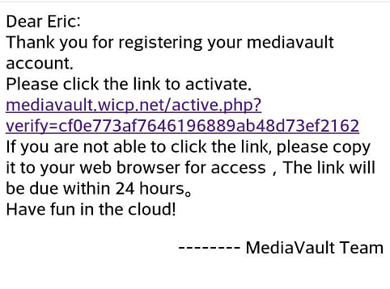
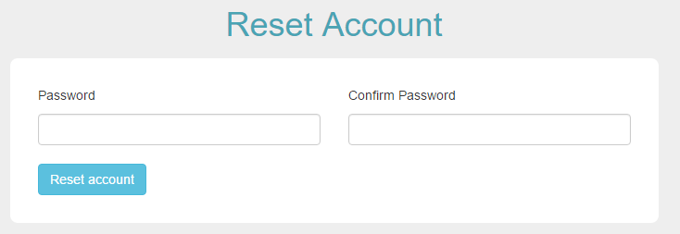

- Photo upload function: I did photo upload function as well. I released upload, picture display, and delete picture functions. That means users can upload their pictures to the cloud and look them online. And I tried to connect to the database so that the id, name and upload address of photos’ will be saved in it. So, when I use php get data from database, pictures will be shown in the display box in chronological order.
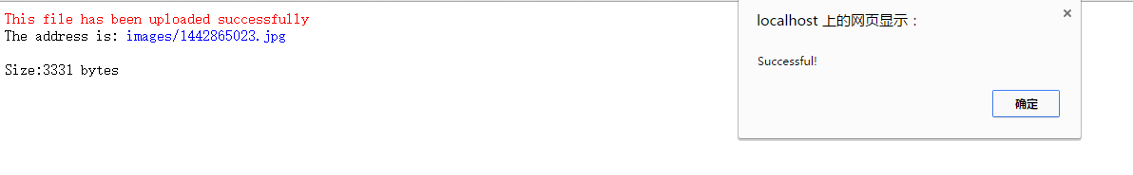
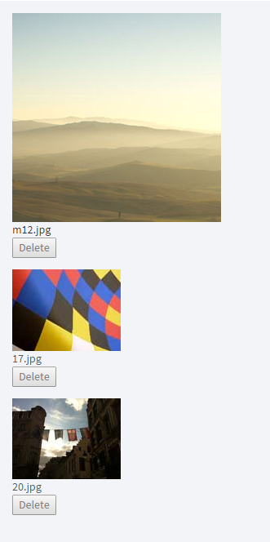

- Test: 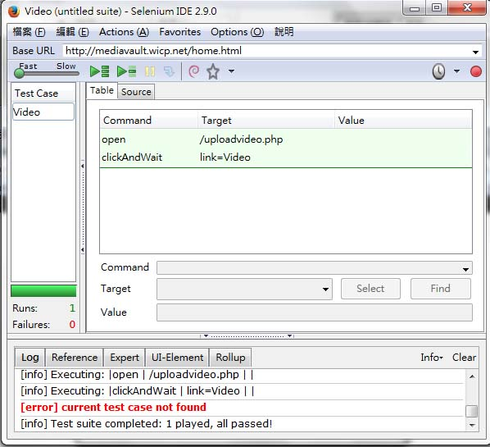

This test is to test if users can open the video site. Obviously, it works!
Users can upload some media files to the video folder and these files will be shown in the display box. Also, users can watch video online. All functions have been released.
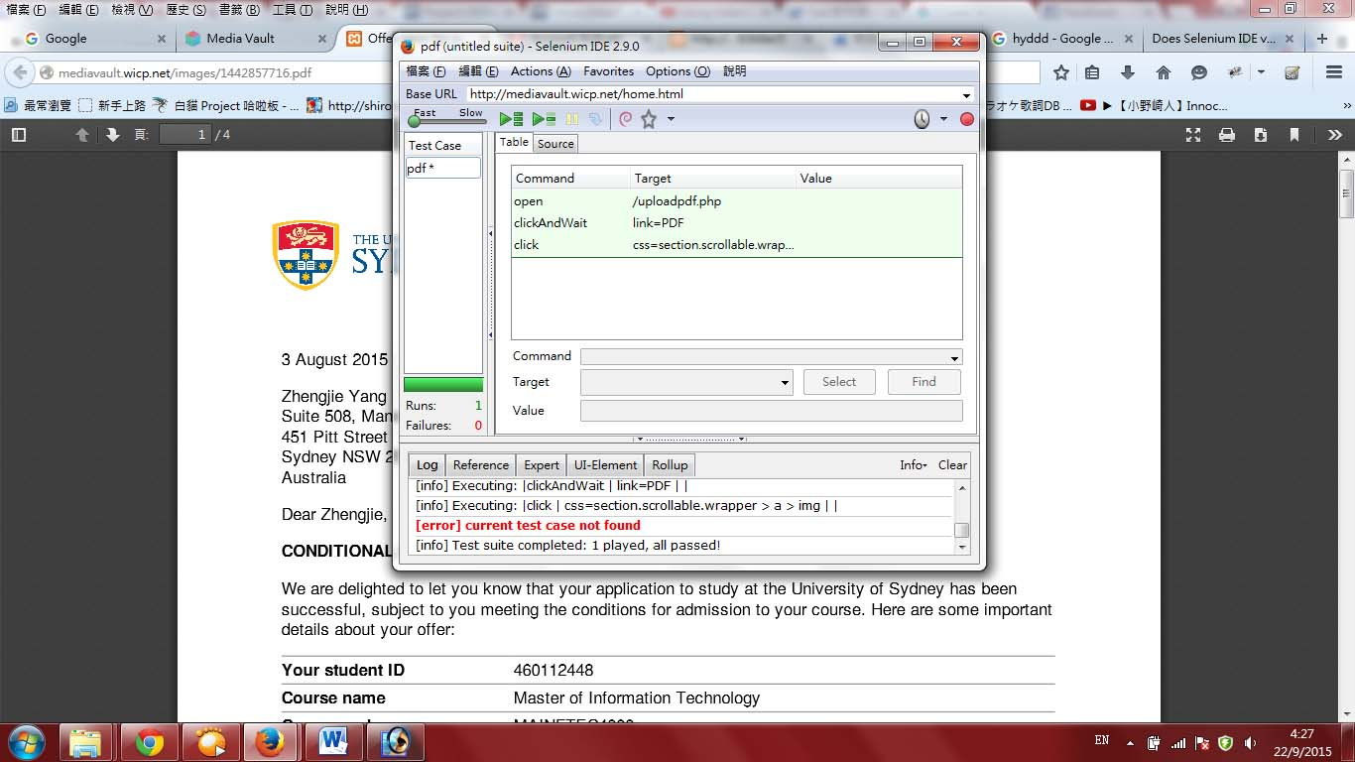
This test is to test if users can upload the e-books. Obviously, It works!
Users can upload their e-books to the pdf folder and see all pdf files are displayed in the display area. At the same time, users can read the pdf online. All functions have been released!

